**Studio Reservation System**

# **Project Proposal**

## **Aims of the Project**

* Provide users seamless, accessible and reliable platform to reserve/book studio’s room.
* Ensure remarkable business revenue and productivity by providing better customer experience.

# **Objectives of the Project**

* Develop a secure web based automated system to manage studio reservation/booking.
* Ensure user’s privacy and safety requirements.

# **Scope of the Project**

The scope of this project consists of creating a web based solution which will enable its users to book/reserve studio’s room/space.

# **Project Duration**

Estimated project duration for the Studio Reservation System would be from 13th September 2021 – 20th October 2021 which is approximately 23 working days.

# **Things that are out of the Scope**

Things that are out of the scope for the first phase of development are as follows:

1. Reservation Cancellation: Staffs or Admin would not be able to cancel reservation for the customers.
2. Campaign: Staffs or Admin would not be able to manage campaigns.
3. Frontend coding won’t be executed (By Bangladesh Team) only backend APIs will be provided.
4. Server Deployment won’t be carried out (By Bangladesh Team).

# **Project Plan**

## **Work Breakdown Structure**

The Work Breakdown Structure of the Studio Reservation System is given below:

## 

Figure Studio Reservation System's Work Breakdown Structure

## **Critical Path Analysis**

According to the significance, duration, priority and difficulty level the following tasks (highlighted with red color) are identified as the Critical Path for the project.

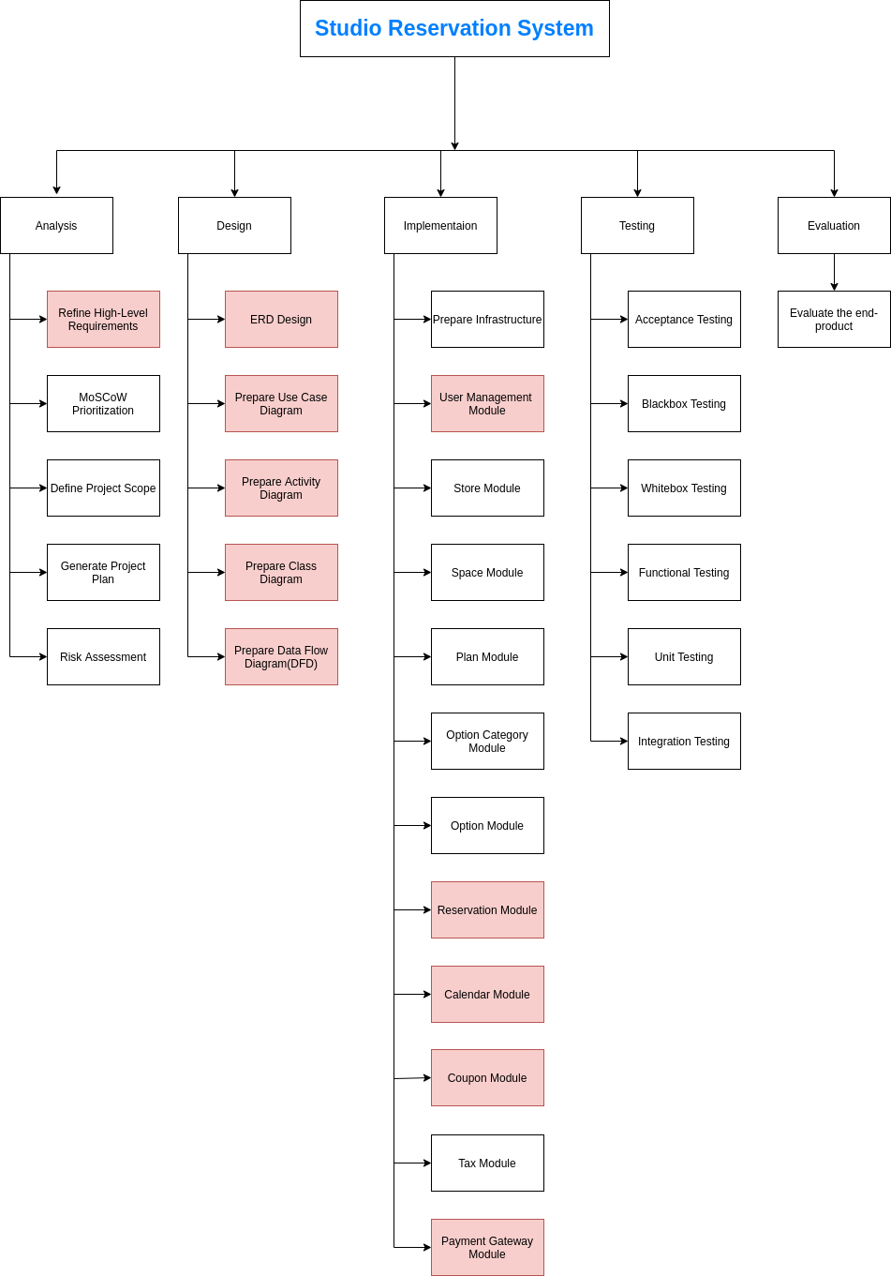

Figure Studio Reservation System's Critical Path Analysis

# **Risk Assessment**

**Likelihood**- Probability of risk occurrence.

**Impact**- Impact on the project.

**Severity**- How severe the outcome will be.

|  |  |  |  |
| --- | --- | --- | --- |
| *Risk Specification* | *Likelihood* | *Impact* | *Severity* |
| Inappropriate time management | Medium | High | High |
| Communication gap between Japan and Bangladesh Team | High | Very High | Very High |
| Failure to implement | Low | High | High |
| Damage of working device | Low | Medium | Medium |
| Security issue | Medium | High | High |
| Data loss | Low | Medium | High |
| Developers getting sick | Low | Very High | High |
| Developers messed up or feeling stressed | Very High | Very High | Very High |
| Improper working environment | Low | High | Medium |

# **Change Management**

The Studio Reservation System project will be developed by following Agile Methodology (Scrum). So, the development will be managed by following sprint. Each sprint will have 7 working days. While developing the project, there may require some changes which needs to be made to achieve the desired outcome. If any changes require, it will be analyzed and there must be some proven justification for the change to be adopt. If the changes that needs to be made is justified and within the project scope, then it will be executed in future iteration as Agile supports iterative development.

Changes that will be allowed are as follows:

* Relevant changes supporting ***project scope***.
* Changes that won’t bring a noticeable alteration in ***time-box*** and could be managed within the deadline.
* Changes that won’t introduce additional ***risks*** rather could minimize possible risk factors.
* Changes that won’t affect rather could improve ***software quality***.

# **Foundation**

## **Software Modules**

The main modules of **Studio Reservation System** would be as follows:

1. User Management Module

1.1 Customer Management Module

1.2 Admin/Staff Management Module

1. Store Module

2.1 Space/Room Module

2.1.1 Product/Plan Module

2.2 Option Category Module

2.2.1 Option Module

1. Reservation Module
2. Calendar Module
3. Collective Deal/Coupon Module
4. Tax Module
5. Payment Gateway Module
6. Campaign Module

## **Software Requirements**

### **Functional Requirements**

The Functional Requirements of the Studio Reservation System are as follows:

|  |  |  |
| --- | --- | --- |
| ***Module*** | ***ID*** | ***Requirement Description*** |
| **User management** |  |  |
|  | FR1 | **Admin Staffs** and **Super Admin** should be able to register new customers, search and modify their information. |
|  | FR2 | **Super Admin** should be able to create Admin Staffs with assigning their roles and permissions and should be able to manage them. |
| **Store** |  |  |
|  | FR3 | **Super Admin** should be able to register and manage stores. |
| **Space/Room** |  |  |
|  | FR4 | **Super Admin** should be able to register and manage rooms/spaces. |
| **Plan/Product** |  |  |
|  | FR5 | **Super Admin** should be able to register plans/products with their prices and manage them. |
|  | FR6 | **Non-members** and **Members** should be able to search for plans by dates. |
| **Option Category** |  |  |
|  | FR7 | **Super Admin** should be able to register and manage option categories. |
| **Option** |  |  |
|  | FR8 | **Super Admin** should be able to register and manage options. |
| **Calendar** |  |  |
|  | FR9 | **Super Admin** should be able to manage calendars including holiday registration and should be able to manage business hours. |
| **Coupon** |  |  |
|  | FR10 | **Super Admin** should be able to manage conditions for coupons, register and manage coupons. |
| **Reservation** |  |  |
|  | FR11 | **Admin Staffs** and **Super Admin** should be able to create reservation for the customers, search and modify them. |
|  | FR12 | **Members** should be able to reserve studio by selecting plans. |
|  | FR13 | **Admin Staffs** and **Admin** should be able extend reservation hours for the customers to use the room and should be able to manage their prices for the use. |
|  | FR14 | **Admin Staffs** and **Admin** should be able to cancel customer’s reservation/booking. |
| **Tax** |  |  |
|  | FR15 | **Super Admin** should be able to manage tax information. |
| **Payment Gateway** |  |  |
|  | FR16 | **Admin Staffs** and **Super Admin** should be able to receive customer’s payment through ***Stripe*** *payment gateway.* |
| **Campaign** |  |  |
|  | FR17 | **Admin Staffs** and **Super Admin** should be able to manage campaigns. |

### **Non-Functional Requirements**

The Non-Functional Requirements of the Studio Reservation System are given below:

1. The system would keep track of any suspicious activity and unsuccessful attempts of users.
2. Intellectual Property Rights and Privacy of Information would be audited.
3. Relevant information, content and context would be carried out throughout the system.
4. Appropriate grammatical uses and familiar terminologies would be used.
5. The system would support user’s mental model.
6. The system would provide appropriate feedback and messages to its users based on their actions.
7. The system would be robust, secure, reliable, usable and maintainable.

### **MoSCoW Prioritization**

|  |  |  |
| --- | --- | --- |
| ***ID*** | ***Requirement Description*** | ***MoSCoW Prioritization*** |
| FR1 | **Admin Staffs** and **Super Admin** should be able to register new customers, search and modify their information. | **Must Have** |
| FR2 | **Super Admin** should be able to create Admin Staffs with assigning their roles and permissions and should be able to manage them. | **Must Have** |
| FR3 | **Super Admin** should be able to register and manage stores. | **Must Have** |
| FR4 | **Super Admin** should be able to register and manage rooms/spaces. | **Must Have** |
| FR5 | **Super Admin** should be able to register plans/products with their prices and manage them. | **Must Have** |
| FR6 | **Non-members** and **Members** should be able to search for plans by dates. | **Should Have** |
| FR7 | **Super Admin** should be able to register and manage option categories. | **Must Have** |
| FR8 | **Super Admin** should be able to register and manage options. | **Must Have** |
| FR9 | **Super Admin** should be able to manage calendars including holiday registration and should be able to manage business hours. | **Should Have** |
| FR10 | **Super Admin** should be able to manage conditions for coupons, register and manage coupons. | **Should Have** |
| FR11 | **Admin Staffs** and **Super Admin** should be able to create reservation for the customers, search and modify them. | **Must have** |
| FR12 | **Members** should be able to reserve studio by selecting plans. | **Must Have** |
| FR13 | **Admin Staffs** and **Admin** should be able extend reservation hours for the customers to use the room and should be able to manage their prices for the use. | **Could Have** |
| FR14 | **Admin Staffs** and **Admin** should be able to cancel customer’s reservation/booking. | **Won’t Have** |
| FR15 | **Super Admin** should be able to manage tax information. | **Must Have** |
| FR16 | **Admin Staffs** and **Super Admin** should be able to receive customer’s payment through ***Stripe*** *payment gateway.* | **Should have** |
| FR17 | **Admin Staffs** and **Super Admin** should be able to manage campaigns. | **Won’t Have** |